Kevin Hudson

Seattle University

WATS3020

November 19th, 2016

**Abstract**

For the Final project, the main focus will be on the use of JQuery, Json, Bootstrap, and JavaScript to develop a beautiful elegant product page for a new card game that I will be publishing next year. This is no the final design document and anything here can be subjected to change.

**Concept**

This is a project that will be designing and building a product page for a fun family card game called Hexalink. This game is currently in the final stages of development and is almost ready for mass production. The product page will have three different parts to it:

1. Header – which consists of menus navigational and informational.
2. Body – Which consists of the product information as well as relevant data pulled from Kickstarter or other crowdfunding sources.
3. Footer – Which consists of navigational items.

The main theme color will be the same as the company logo which consists of yellow, green, and black. The background color will be in black or a very dark grey color. The product page will have a carousel style picture about 500 px wide displaying different parts of the card game in action. Next to that will be an explanation of the product. Underneath the product information will be a carousel slider of relevant Kickstarter, or other crowdsource campaigns, products that are live. Below is a wireframe drawing of the current concept.

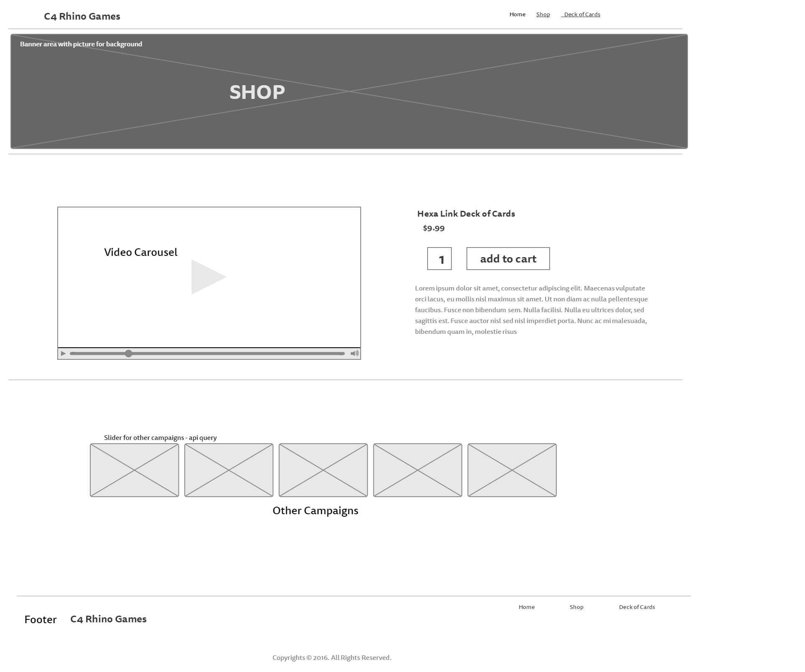

Figure Web view Wire Frame.

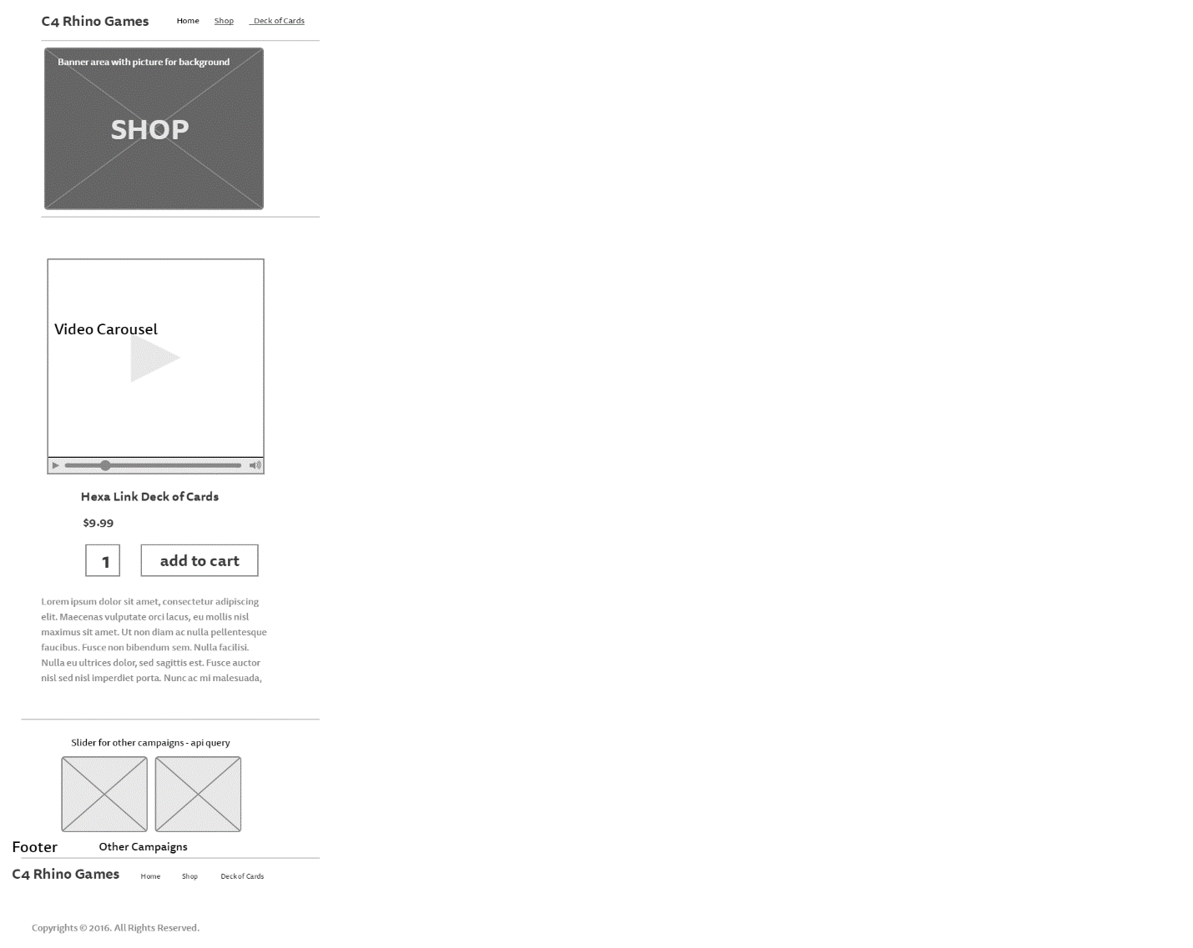

Figure . Mobile View Wire Frame

Additional info for design:

1. Fonts – Primary Font: Open Sans, Secondary Font: Federant.
2. Font size – Variable accept for Title fonts which will be 27 Px. Mean font size will be 14px.
3. Font Colors - will be in a yellow and green mix.
4. Menu Bar – will be fixed.
5. CASE tools and libraries - Code anywhere, Bootstrap, JQuery, JavaScript. Bash Terminal.
6. Server – Digital Ocean.
7. API for crowdsourcing websites.